1.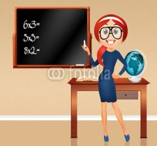 2.3.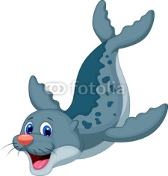 4.
a. classroom a. actor a. seal a. table
b. teacher b. farmer b. whale b. bed
c. student c. doctor c. fish c. chair
5. 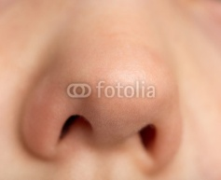 6.7.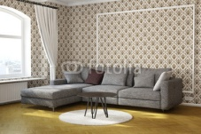 8.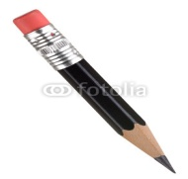
a. mouth a. pen a. bedroom a. pen
b. nose b. book b. living room b. pencil
c. ear c. pencil c. dining room c. rubber
9.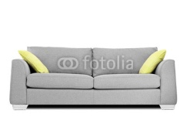 10.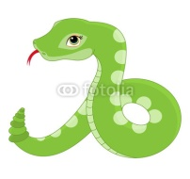 11.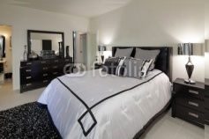 12.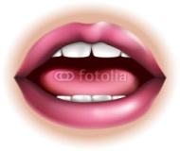
a. table a. seal a. bedroom a. arm
b. chair b. snake b. bathroom b. nose
c. sofa c. crocodile c. living room c. mouth

13.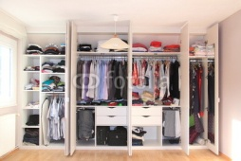14.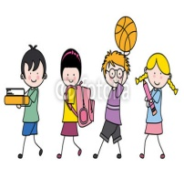15.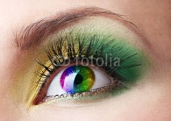16.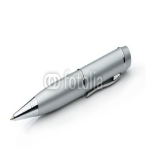
a. wardrobe a. mothers a. ear a. pencil
b. bed b. children b. eye b. pen
c.desk c. uncles c. arm c. ruler
17.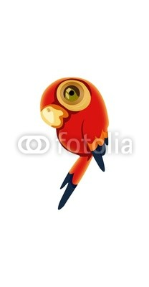18.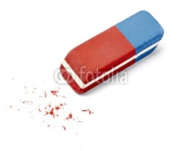19.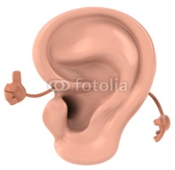20.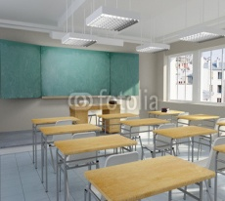
a. elephant a. rubber a. eye a. bedroom
b. seal b. ruler b. arm b. bathroom
c. parrot c. notebook c. ear c. classrooom
21.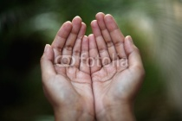22.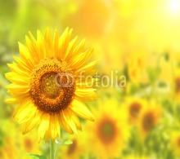23.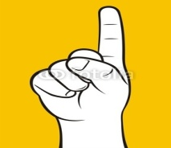24.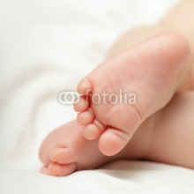
a. hands a. sun a. arm a. hands
b. arms b. flower b. foot b. feet
c. feet c. tree c. finger c. hands
25.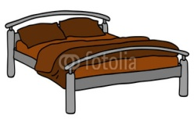26.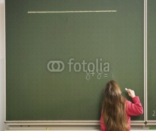27.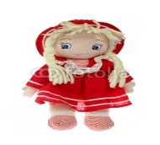28.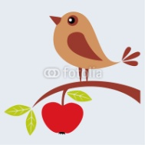
a. bath a. bath a. doll a. bed
b. bed b. board b. ball b. bird
c. sofa c. bed c. bed c. ball
29.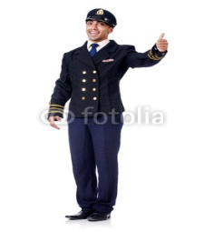30.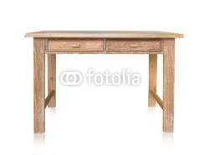31.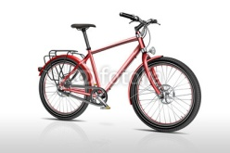32.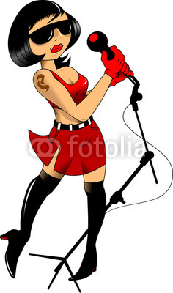
a. farmer a. table a. bike a. police officer
b. pilot b. wardrobe b. car b. singer
c. actor c. sofa c. doll c. farmer
33.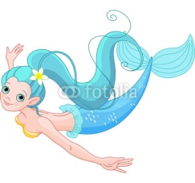34.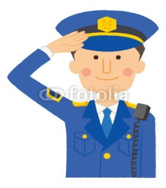35.36.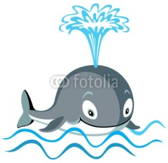
a. girl a. police officer a. actor a. seal
b. teacher b. actor b. waiter b. whale
c. mermaid c. mermaid c. police officer c. bat
37.38.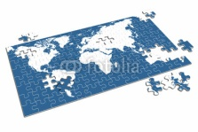39.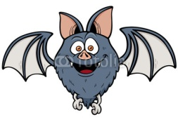40.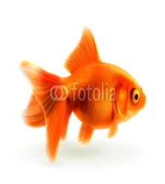
a. jigsaw puzzle a. jigsaw puzzle a. bat a. bat
b. computer b. doll b. whale b. fish
c. doll c. bat c. fish c. seal
41.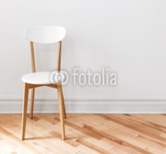42,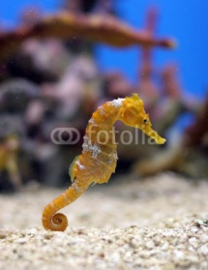43.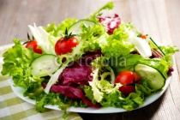44.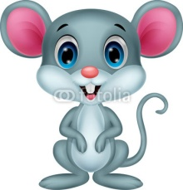
a. sofa a. seahorse a. bread a. mouse
b. chair b. whale b. chicken b. monkey
c. bed c. fish c. salad c. hat
45.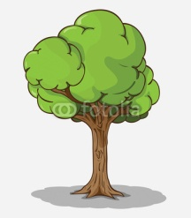46.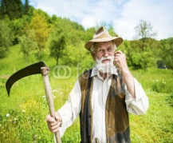47.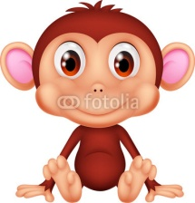48.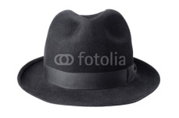
a. flower a. farmer a. monkey a. shirt
b. hat b. waiter b. mouse b. hat
c. tree c. pilot c. seahorse c. skirt
49.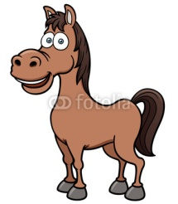50.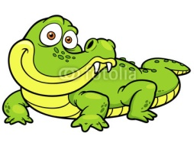51.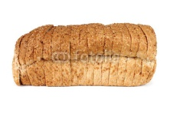52.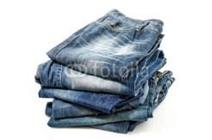
a. horse a. fish a. bread a. shirts
b. mouse b. crocodile b. cherry b. jeans
c. monkey c. horse c. orange c. shoes
53.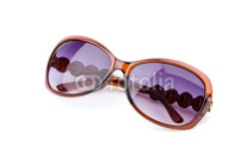54.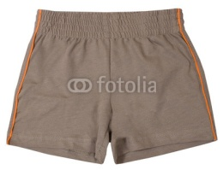55.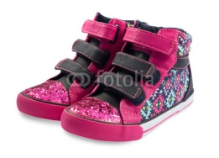56.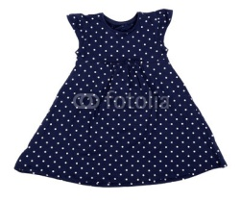
a. glasses a. glasses a. shorts a. dress
b. jeans b. shorts b. shoes b. skirt
c. shoes c. jeans c. socks c. shirt
57.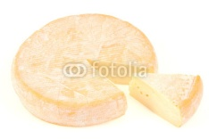58.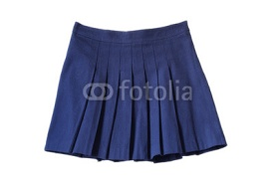59.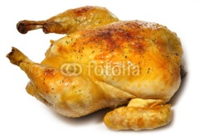60.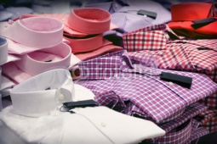
a. cheese a. skirt a. cheese a. shirts
b. bread b. shirt b. chicken b. skirts
c. water c. T-shirt c. fish c. dresses
61.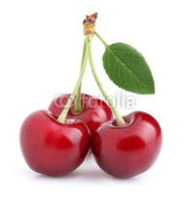62.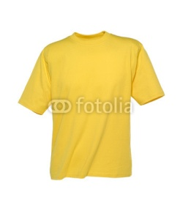63.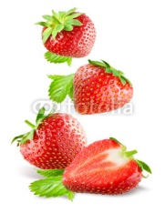64.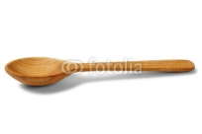
a. strawberries a. skirt a. cherries a. knife
b. oranges b. dress b. apples b. spoon
c. cherries c. T-shirt c. strawberries c. fork
65.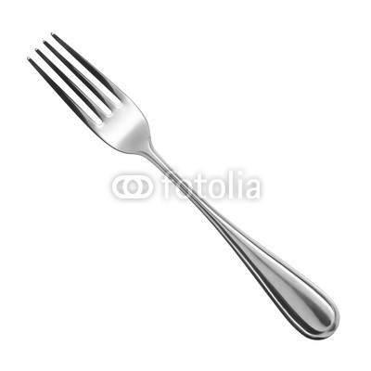66.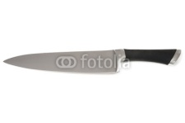67.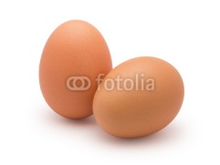68.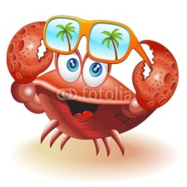
a. knife a. knife a. egg a. seahorse
b. spoon b. spoon b. apple b. crab
c. fork c. fork c. bread c. fish
69.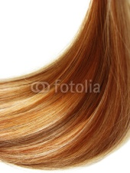 70.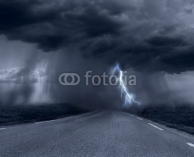 71.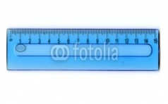
a. mouth a. it’s windy a. ruler
b. arm b. it’s rainy b. rubber
c. hair c. it’s snowy c. book

72. December is in the 73. May is in the 74. July is in the
a. winter a. winter a. winter
b. autumn b. summer b. summer
c. spring c. spring c. spring

75. 13 is 76. 12 is 77. 40 is 78. 90 is
a. thirty a. twelve a. four a. ninety
b. thirteen b. twenty b. fourteen b. nine
c. three c. twenty-two c. forty c. nineteen
79. a. happy 80. 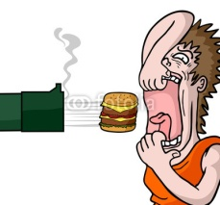a. hungry
b. Thirsty b. Happy
81. What’s .........name? 82. How..........are you?
a. you a. old
b. your b. years
c. I c. Can

83. My mother.....tall. 84. The children......tired.
a. is a. am
b. are b. is
c. am c. aren’t

85. Monica .....nine years old. 86. The men ..... short.
a. is a. aren’t
b. are b. isn’t
c. am c. is

87. .......you happy? 88. .......Monica sad?
a. am a. am
b. is b. is
c. are c. are

89. ........you and Jeff hungry? 90. My feet..............big
a. am a. am
b. is b. is
c.are c. are

91. That man......long hair. 92. We..........a good teacher.
a. have got a. have got
b. has got b. has got
c. haven’t got c. hasn’t got

93. ......you got a pencil? 94. The girls.......got dolls.
a. Have a. have
b. Has b. has
c. Hasn’t c. hasn’t

95. .............we got homework? 96. Look! The baby....walk!
a. Have a. can
b. Has b. has got
c. Hasn’t c. is

97. .......run! 98. Thomas .......dance. He is tired.
a. Don’t a. don’t
b. Must b. can’t
c. Can c. must

99. Paula is a singer. She..... 100. ..................the door, please.
sing well.
- do a. Close
- can b. Can
- has got c. Don’t
101-120
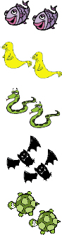
Seals fly. a. can b. can’t

Snakes smell. a. can b. can’t

Turtles jump. a. can b. can’t
Bats hear. a. can b. can’t
Fish swim. a. can b. can’t

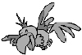 This is/ That is a bird.
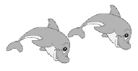 These are/ Those are dolphins.

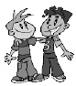 These are/ Those are boys.
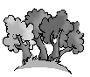 This is/That is a forest

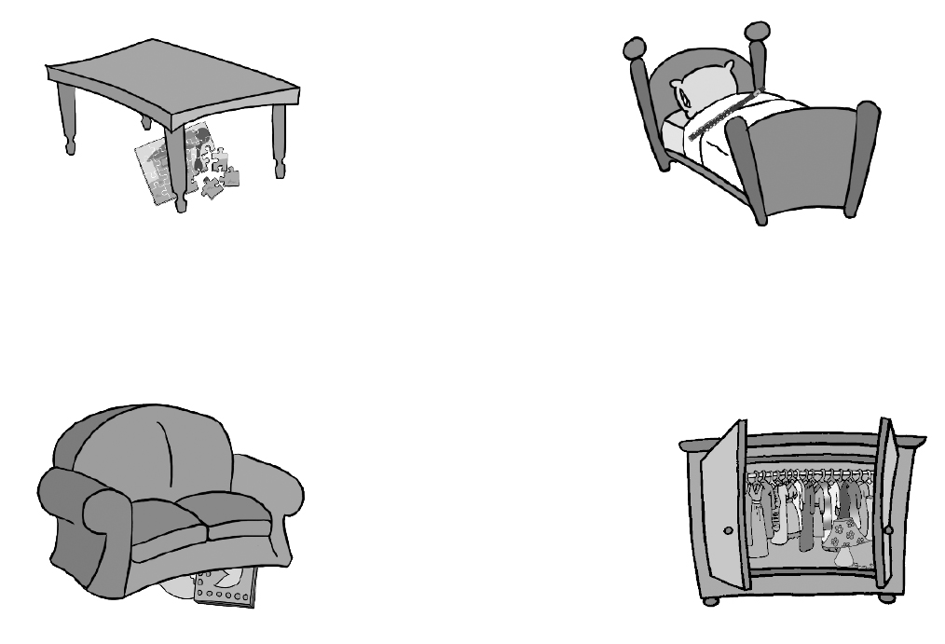

1.

The flute is __________
the bed.

The jigsaw puzzle is
the table.
- On b. under c. in

The computer game is
the sofa.
- On b. under c.in
The lamp is
the wardrobe.
- On b. under c. in

- Look and tick
a She’s wearing a dress.
b She’s wearing a skirt.

a He’s wearing a hat.
b He’s wearing glasses.

a He’s wearing trousers.
b He’s wearing shorts.

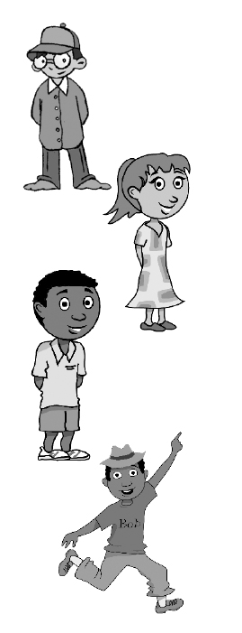
a He’s wearing a jumper.
b He’s wearing a shirt.

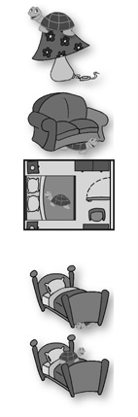
1. Toto’s ______the lamp.
a. on b. in c. under

2. Toto’s the sofa.
a. on b. in c. under
3. Toto’s the bedroom.

4. Toto’s the bed.

5. Toto’s the bed.

1.

Read and circle.
- There are some / any plates and forks on the table.

- Is there some / any chocolate in your bag?
123.There aren’t some / any noodles on the plate.
124.There’s some / any yoghurt on the table.
125.Are there some / any vegetables in the bag?
126.There isn’t some / any rice on the plate.

127. a. He is drinking milk b. He is eating

128. a. She is drinking milk b. She is eating
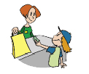129. a. She is playing ball b. She is buying

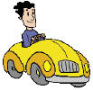 130. a. He is riding a bike b. He is driving a car
131. a. They are playing ball b. They are walking

132. Susan………………..bananas.
a. like
b. likes
133. The women…………….dresses.
a. like
b. like
134. Steven …………………cherries.
a. like
b. don’t like
c. doesn’t like
135. I ……….carrots.
a. likes
b. don’t like
c. doesn’t like
136. This is ……..airplane
a. a
b. an
137. That is …..orange car.
a. an
b. a
138. There is a house. …….house is big.
a. a
b. the
c. an
139. There….. a mouse in the house.
a. is
b. are
140. There……..two apples on the table.
a. is
b. are
141. ………….there any water?
a. is
b. are
142. There are ten ……….in the kitchen.
a. knifes
b. knives
143. I can see two…………….in the forest.
a. foxies
b. foxes
144. The ………are red.
a. tomatos
b. tomatoes
145. The ………..are funny.
a. monkeys
b. monkies
146. The ………………are sleeping.
a. babys
b. babies
147. How ………………..dogs can you see?
a. many
b. much
148. How ……………….oranges are there?
a. many
b. much
149. How…………………..water is there?
a. many
b. much
150. How ………………spoons are there?
a. many
b. much
151. How…………………..bread is there?
a. many
b. much
152. John…………………….football on Sunday.
a. play
b. plays

153. We ………………….spaghetti on Friday.
a. eat
b. eats
154. Simon……………………….ride a bike.
a. doesn’t
b. don’t

155. …………you watch tv every day?

- Does b. do

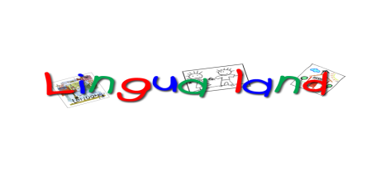
A & B Junior-Final Test

Name……………………………………………

Good Luck!!!

